**Assignment -1**

1. Create a web page that shows a message “This is my first HTMLpage”.

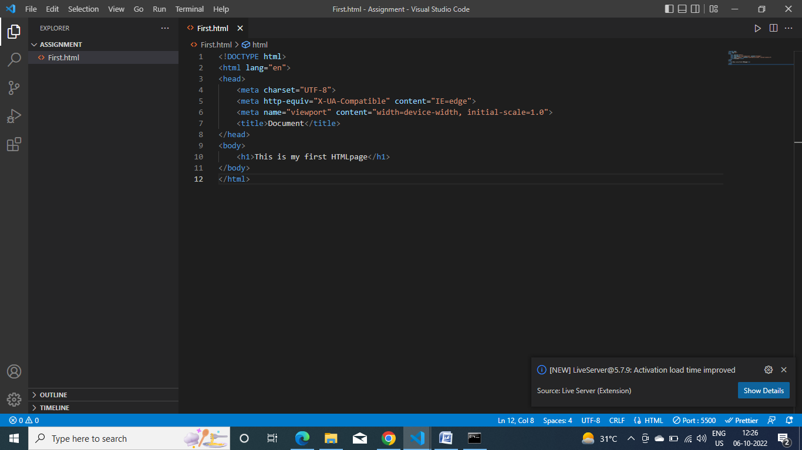

1. .Create Registration Form of bank Using HTML and CSS.

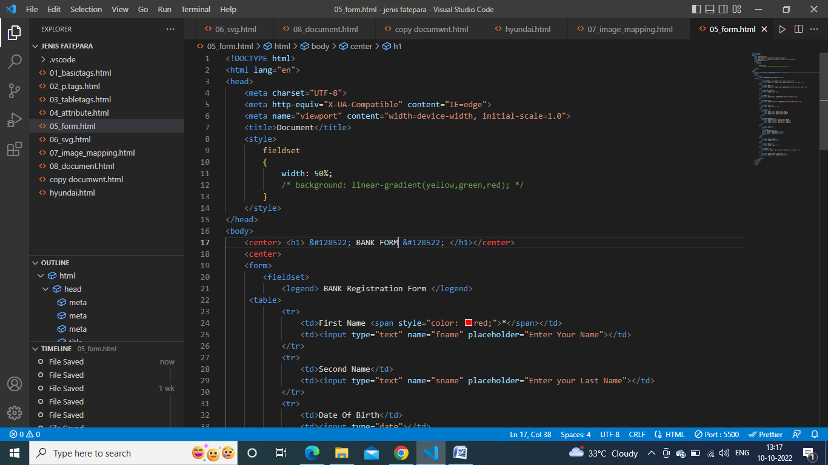

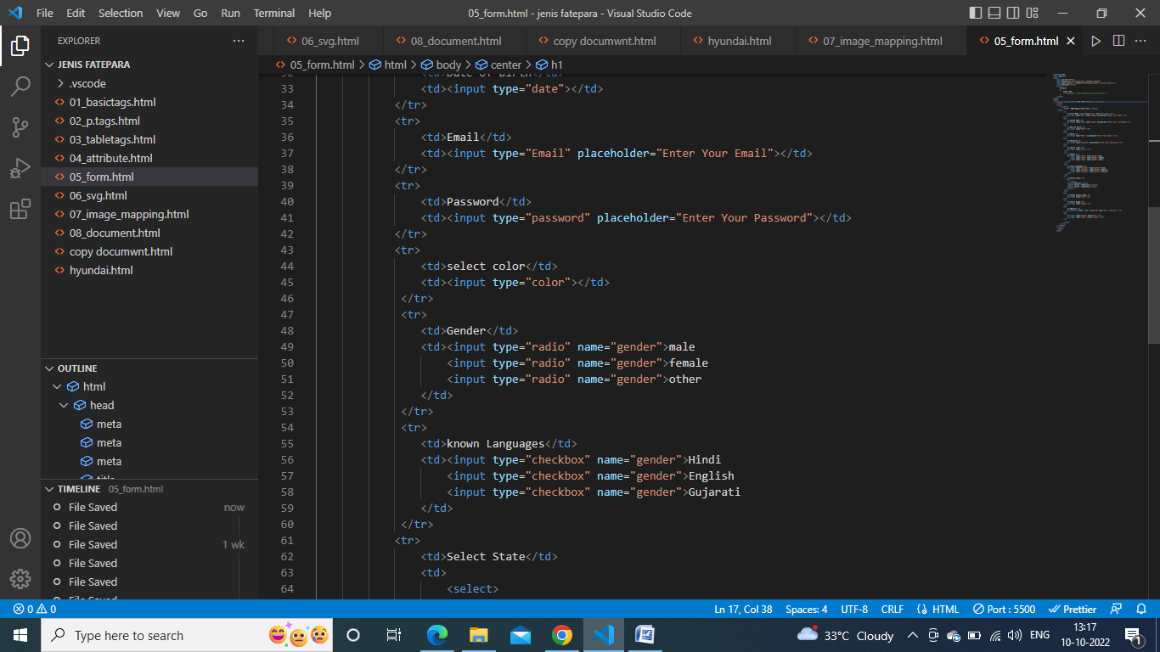

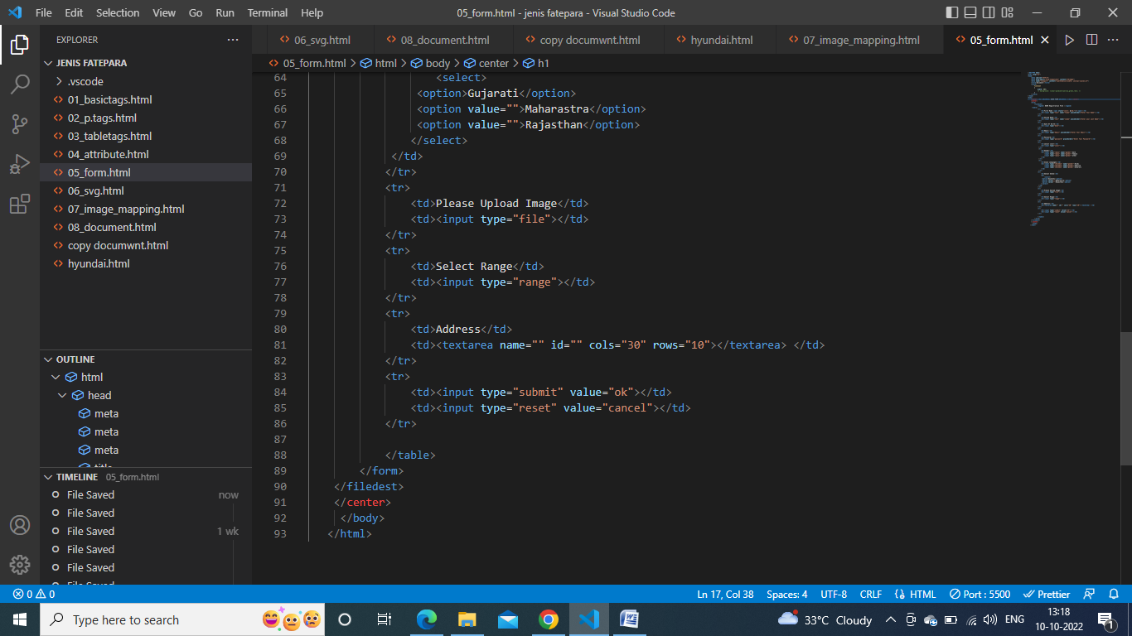

1. **How to specify the column properties of each column within a colgroup element?**

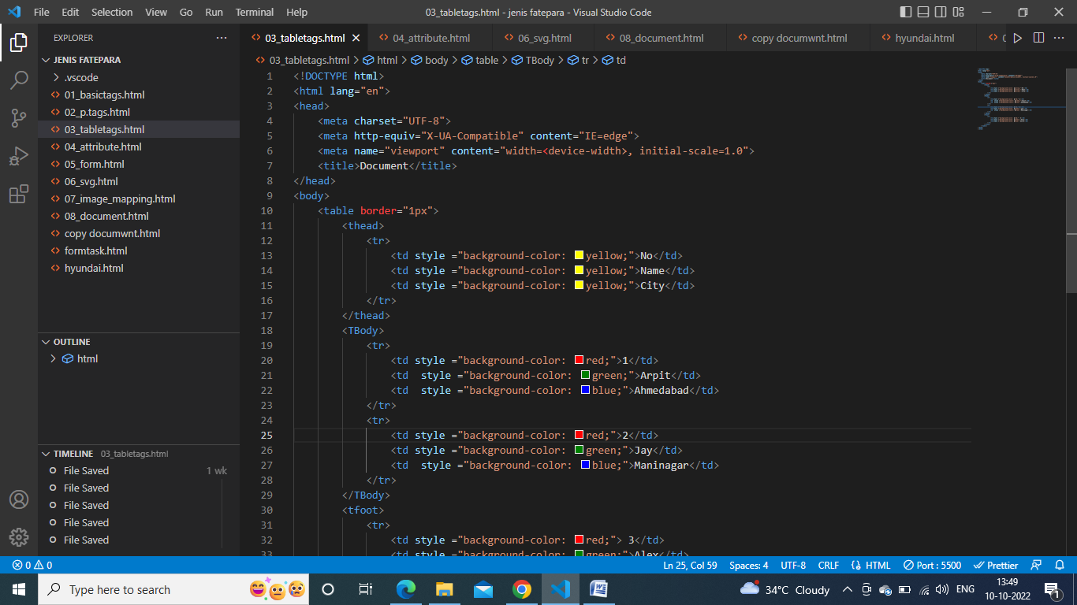

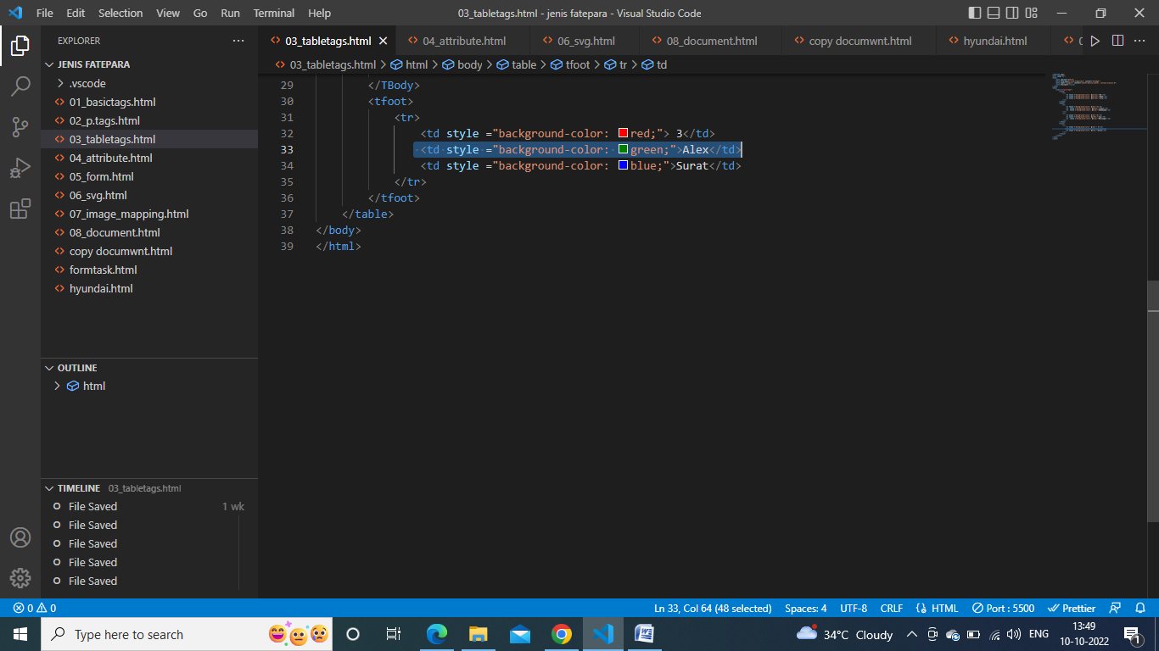

1. **How to define accuontainer for an external(non-HTML)application?**

The approach of this article is to define a container for an external application by **using a <embed> element in the Document**. This is used for embedding external application which is generally multimedia content like audio or video . It is used as a container for embedding plug-ins such as flash animations.

1. **How to define an option in a drop-downlist?**

**The HTML <option>** tag is used within a form for defining options in the drop-down list.

1. **How to underline a text in an HTML document?**

The **<u> tag** in HTML stands for underline, and it's used to underline the text enclosed within the <u> tag.

1. **Create elastic Page Layout**

